Question 1:

# **Greyscale enhancement via point processing:**

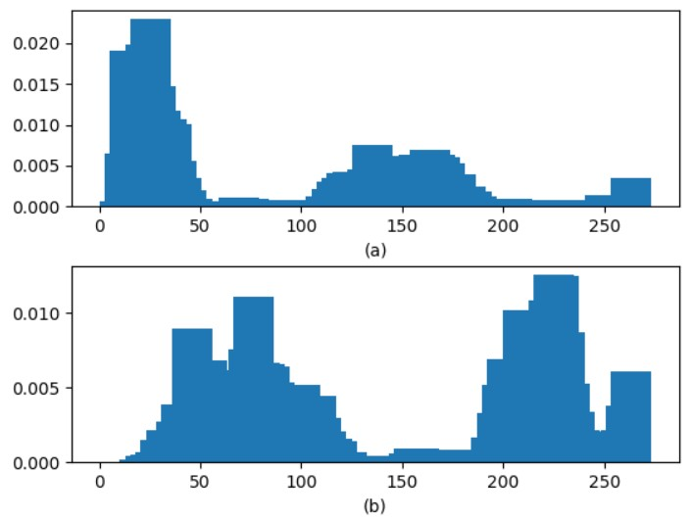The output figures for enhancing greyscale images are given below